*Gaurav Ramesh Savanur*

*web design*

PROJECT: Website

Student id:17114357

Link to the website: <https://gsavanur.000webhostapp.com/>

**REQUIREMENT SPECIFICATIONS FOR THE WEBSITE**

1.What is the objective of this website?

The objective of this website is to encourage students to participate in competitive programming where students are given real –world problems and therefore enhance their problem-solving skills

2.Where will the website be deployed?

The website will be deployed on 000webhost

3.What would be required in the home page?

The home page contains the basic information of this competition and will contain an image

4.What would be the contain in the about page?

THE ABOUT page will contain the general rules of this programming competition and will show a YouTube clip of the previous year’s competition.

5.What would be present in the project page?

This page would provide more information on competitive programming and would contain a list of past problems.

6.What content would be present in the contact page?

The contact page would contain the map and form. It would further contain information like Address, phone number and email.

7.When would the project be submitted?

The project would be submitted on 22nd December

**WIREFRAMES**:

Desktop friendly

**Home page:**



**About Page:**

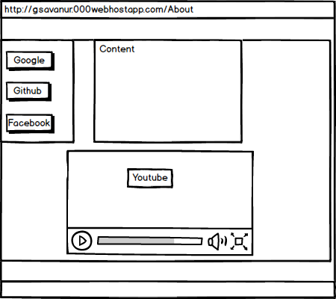

**Projects Page:**

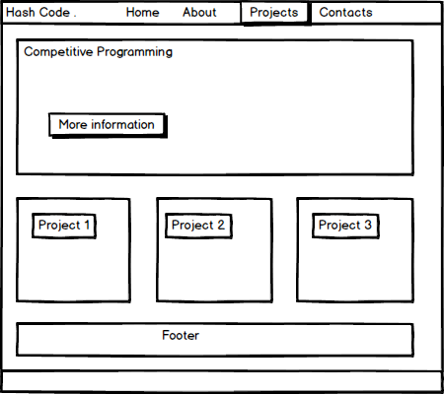

**Contacts Page:**

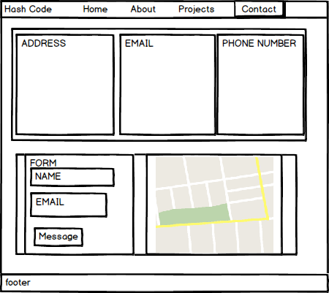

**Mobile Friendly pages:**

**Home page**

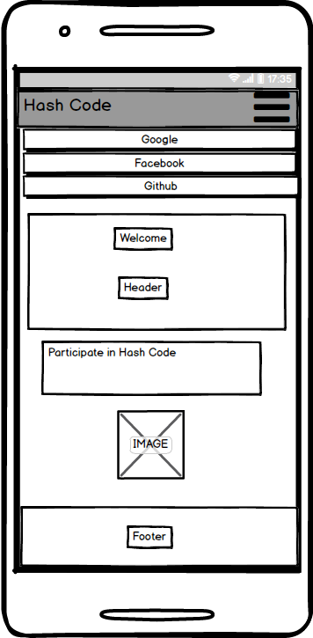

**About Page:**

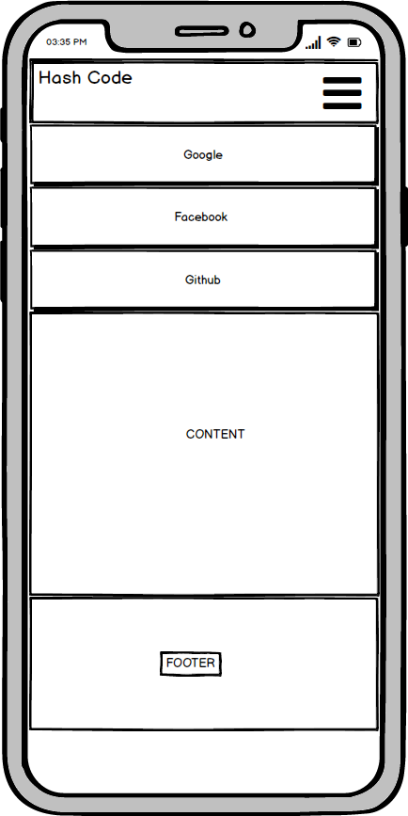

**PROJECTS PAGE:**

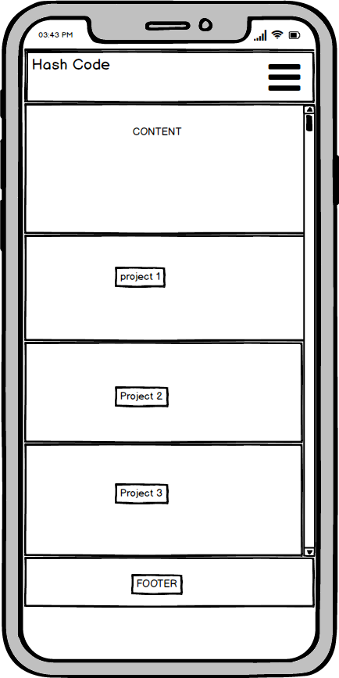

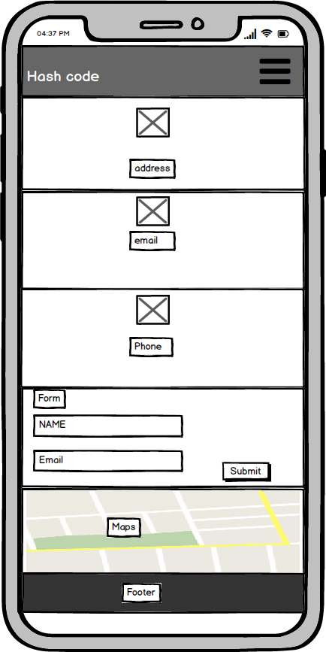**CONTACTS PAGE:**